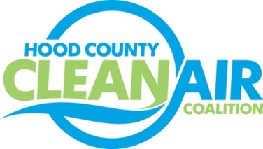
Meeting: Thursday, April 5, 2018
Neely House
304 East Rucker Street, Granbury, Texas 76048
8:30-10:00 a.m.

Agenda

- Call Meeting to Order
- Annual Board Member Nominations and Officer Elections
- EPA Updates – Randy Pitre, EPA
- Local Updates – Michelle McKenzie
  - Review of February and March Meeting Summary
  - Review of Projects
    - Monthly Budget Review for January and February
    - Status of Projects FY 16/17/18
    - Office Status
  - Alternative Funding Status
  - Reports
    - March Ozone Update
    - Texas Regional Air Quality Meeting in March
  - Consideration of VW Comment for TCEQ
5.) Regional Updates – Michelle McKenzie
  - Clean Air Action Day on June 22: www.airnorthtexas.org/cleanairactionday
  - SECO Free Technical Assistance and Energy Assessments to Local Governments and Schools for Improving Energy Efficiency or Reducing Costs.
  - The TCEQ Natural Gas Vehicle Grant Opening soon - Program Expanded to Include Propane as well as CNG and LNG. More information at: https://www.tceq.texas.gov/airquality/terp/tngvgp.html
  - Funding Opportunities, www.nctcog.org/aqfunding
6.) Other Discussion
7.) Adjourn

